JANUARY 6, 2026
BOARD MINUTES

Pursuant to motion of adjournment, the Polk County Board of Commissioners met in regular session at 8:00 o’clock a.m., January 6, 2026. Members present: Commissioner Paul Reese, Commissioner Gary Willhite, Commissioner Joan Lee, and Charles S. Whiting, County Administrator, Clerk of the Board. Others present: Samuel Melbye, Deputy Clerk of the Board. District 5 seat vacant. Members absent: Commissioner Warren Strandell

CALL TO ORDER
Joan Lee, Chair of the Board, called the meeting to order and proceeded to call for nominations for the Office of Chairman of the Polk County Board of Commissioners for 2026.

ELECTION OF OFFICERS
The Chair called for nominations for the Office of Chair of the Polk County Board of Commissioners for 2026. Commissioner Reese nominated Commissioner Lee as Chair of the Polk County Board. A motion was made by Commissioner Reese to nominate Commissioner Lee as Chair of the Polk County Board, seconded by Commissioner Willhite and adopted by unanimous vote of the Board. Commissioner Lee assumed the Chair.

The Chair of the Board asked for nominations for the office of Vice-Chair of the Board. A motion was made by Commissioner Willhite to nominate Commissioner Reese as Vice-Chair of the Polk County Board, seconded by Commissioner Lee and adopted by unanimous vote of the Board. Commissioner Reese assumed the Vice-Chair.

AGENDA
A motion was made by Commissioner Reese seconded by Commissioner Willhite and adopted by unanimous vote of the Board to approve the January 6, 2026, agenda with additions to Management Information Systems, Server & Storage Replacement Cost Update; and Highway, Designating Polk County’s website for solicitations of bids, requests for information, and requests for proposals.

CONSENT ITEMS
A motion was made by Commissioner Willhite seconded by Commissioner Reese and adopted by unanimous vote of the Board to approve the January 6, 2026, consent items:
- Approve December 16, 2025, Board minutes.
- Approve Auditor Warrants.

COUNTY BOARD MEMBER ISSUE FORUM
- Approve Resolution (2026-05) Designating Delegates to the Association of Minnesota Counties & Payment of Dues.

RESOLUTION (2026-05)

Designating Delegates to the Association of
Minnesota Counties & Payment of Dues

The following resolution (2026-05) was offered by Commissioner Reese:

WHEREAS, The Board of County Commissioners of Polk County, Minnesota, has availed itself of the authority granted under Section 375.163, M.S.A., and will pay the dues of said County to the State and National Association of County Commissioners for the year 2026, and it is the intention of said Board of County Commissioners to designate individuals to attend meetings of said Association.

NOW THEREFORE BE IT RESOLVED, That the Board of County Commissioners of Polk County, Minnesota, does hereby designate all of its members as delegates from said County to serve on various committees of that Association.

BE IT FURTHER RESOLVED, That upon presentation of a properly verified claim, the finance department be and hereby is authorized to reimburse each of said person for their actual and necessary expenses in attending such meetings, and to pay the annual dues of the County for membership in the Association of Minnesota Counties.

BE IT FURTHER RESOLVED, That the following named individuals are Polk County's official delegates to the Association of Minnesota Counties: Commissioner Reese; Commissioner Strandell; Commissioner Willhite; Commissioner Lee; Charles S. Whiting, County Administrator; Samuel Melbye, County Director of Property Records; and Richard Sanders, County Highway/Ditch Engineer.

Commissioner Willhite seconded the foregoing resolution, and it was declared adopted upon the following vote: YEAS: Commissioner Reese, Commissioner Willhite, & Commissioner Lee NAYS: None

- MPO Appointment
A motion was made by Commissioner Willhite seconded by Commissioner Reese and adopted by unanimous vote to appoint Commissioner Strandell as Polk County Representative to the Grand Forks-East Grand Forks Metropolitan Planning Organization.
- Commissioner Reese brought forth that he attended the following meetings:
  - West Central Regional Water District meeting.
  - Received various calls on a variety of subjects from Polk County residents.
- Commissioner Willhite brought forth that he attended the following meetings:
  - Polk, Norman, and Mahnomen Community Health Board meeting.
  - Polk County Extension meeting.
- Commissioner Lee brought forth that she attended the following meetings:
  - Toward Zero Deaths meeting.
  - Polk County Extension meeting.
  - Opioid Funding meeting.
  - Polk, Norman, and Mahnomen Community Health Board meeting.
  - Association of Minnesota Counties (AMC) Solid Waste meeting.
  - East Polk County Development Achievement Center Board meeting.
  - Minnesota African American Family Preservation and Child Welfare Disproportionality Act meeting.

MANAGEMENT INFORMATION SYSTEMS
Levi Webster, MIS Director, came before the Board with matters pertaining to his department:
- Request to Purchase Replacement Firewalls
A motion was made by Commissioner Reese seconded by Commissioner Willhite and adopted by unanimous vote of the Board to approve the SHI quote for the amount of $27,852.00.
- Server and Storage Replacement Updated Cost
The amount of computer memory needed for computers within the County has created an increase in cost. The increase in cost was approved under the authority of the County Administrator and the Board was in agreement with MIS Director Webster moving forward at the new cost.

FACILITIES
Richard Langlois, Facilities Director, came before the Board with matters pertaining to his department:
- Approve Purchas of Haulotte 5533 Towable Manlift
A motion was made by Commissioner Willhite seconded by Commissioner Reese and adopted by unanimous vote of the Board to approve the purchase of the Haulotte 5533 towable manlift from ACME Equipment, Grand Forks, ND in the amount of $49,249.00.

FINANCE
Stacy Grover, Finance Director, came before the Board with matters pertaining to her department:
- Briefing on Revenue Recapture Audit
Discussion was held with the Board regarding the revenue recapture audit results received from the Minnesota Department of Revenue.

PROPERTY RECORDS
Sam Melbye, Director of Property Records, came before the Board with matters pertaining to his department:
- Cannabis Retail Registration
A motion was made by Commissioner Reese seconded by Commissioner Willhite and adopted by unanimous vote of the Board to approve the Retail Registration for The Corner Bar of Climax, LLC. dba The Corner Bar.
- Appointment of Election Judges
A motion was made by Commissioner Willhite seconded by Commissioner Reese and adopted by unanimous vote of the Board to approve the Director of Property Records appoint Elections Judges as needed and required
- Resolution 2026-04 to Establish Absentee/Mail/UOCAVA Ballot Boards
- Appointment of Extension Committee Members
A motion was made by Commissioner Willhite seconded by Commissioner Reese and adopted by unanimous vote of the Board to approve

2026 PUBLICATION BIDS
Pursuant to published notice, bids were opened and publicly read at 9:15 a.m., for the Official Newspaper and the Delinquent Tax List:

Official Newspaper

Bidder Bid Per Column Inch
Crookston Daily Times $
Fertile Journal $
McIntosh Times (Richards Publishing) $

Delinquent Tax List

Bidder Bid Per Column Inch
Crookston Daily Times $
Fertile Journal $
McIntosh Times (Richards Publishing) $
Second Publication of Financial Statement

Bidder Bid Per Column Inch
Crookston Daily Times $
Fertile Journal $
McIntosh Times (Richards Publishing) $

- Resolution (2026-01) Designating the Polk County Official Newspaper

RESOLUTION (2026-01)

Designating the Polk County Official Newspaper

The following resolution (2026-01) was offered by Commissioner:

BE IT RESOLVED, By the Board of County Commissioners of Polk County that the [NEWSPAPER] be and the same is hereby designated by the Board of County Commissioners of Polk County as the Official Newspaper of Polk County for 2026, and as such, is the newspaper designated in which shall be published all notices and publications which the County is required to publish during the year of 2026.

BE IT FURTHER RESOLVED, That the bid of $ per column inch be accepted for the official publications of Polk County.

BE IT FURTHER RESOLVED, That the publication of notices and other publications shall be at the rates as established in the bids and as accepted by the Board.

Commissioner seconded the foregoing resolution, and it was declared adopted upon the following vote: YEAS: NAYS:

- Resolution (2026-02) Designating Publication of the Delinquent Tax List Statement of Polk County

RESOLUTION (2026-02)

Designating Publication of the Delinquent
Tax List Statement of Polk County

The following resolution (2026-02) was offered by Commissioner Reese:

BE IT RESOLVED, By the Board of County Commissioners of Polk County that the
[NEWSPAPER] with a bid of $ per column inch be and the same is hereby accepted for the Publication of the Delinquent Tax List Statement of Polk County to be published in 2026.

Commissioner seconded the foregoing resolution, and it was declared adopted upon the following vote: YEAS: NAYS:

- Resolution (2026-02) Designating Publication of the Delinquent Tax List Statement of Polk County

RESOLUTION (2026-03)

Second Publication of the 2025 Financial Statement

The following resolution (2026-03) was offered by Commissioner :

BE IT RESOLVED, By the Board of County Commissioners of Polk County that the bid of the [NEWSPAPER] for $X.XX per column inch be and the same is hereby accepted for the second publication of 2025 Financial Statement of Polk County to be published in 2026.

Commissioner seconded the foregoing resolution and it was declared adopted upon the following vote. YEAS:. NAYS:

PLANNING & ZONING
Jacob Snyder, Assistant Environmental Services Administrator, came before the Board with matters pertaining to his department:
- Approval of 2026 Polk County Haulers License
A motion was made by Commissioner Reese seconded by Commissioner Willhite and adopted by unanimous vote of the Board to waive the penalty fees and approve
- Final Plat Approval – Clark Nelson Addition
A motion was made by Commissioner Reese seconded by Commissioner Willhite and adopted by unanimous vote of the Board to approve

PUBLIC HEALTH
Sarah Reese, Public Health Director, came before the Board with matters pertaining to her department:
- Opioid Settlement Funds Contracts
  - Tri-County Community Corrections – Reese/Willhite
  - Alluma, Inc. – Willhite/Reese
  - New Heights Elementary School – Reese/Willhite
  - Fosston High School – Willhite/Reese
  - Tri-Valley Opportunity Council, Inc.
A motion was made by Commissioner Reese seconded by Commissioner Willhite and adopted by unanimous consent of the Board to approve
- Approval of Agliti Supplemental Biomedical Services Agreement (renewal)
A motion was made by Commissioner Willhite seconded by Commissioner Reese and adopted by unanimous consent of the Board to approve

HIGHWAY
Richard Sanders, Polk County Engineer, came before the Board with matters pertaining to his department:
- Authorization Allowing Payments to Snow-Wheel Systems, Inc. Via Auditors Warrant – Reese/Willhite
- Approve Purchase of Three Kuhn Mowers from Valley Plains Equipment of Crookston - $17,340/mower Willhite/Reese
- Approve Agreement for Safety Consulting Services with Safety Compliance Services, LLC. - $19,800.00 Reese/Willhite
- Certificate of Performance/Final Acceptance SAP 057-601-012 Pennington County CSAH 1, SAP 060-609-023 (CSAH 9), SAP 060-619-019 (CSAH 19), SAP 060-645-026 (CSAH 45), SAP 063-630-004 Red Lake County (CSAH 30) Hot In-Place Recycle – Reese/Willhite
- Approval to Purchase Low-Hour Used Tractor Including Loader -
- Approval to Full Highway Maintenance II Vacancy –
- New Item** County Website for bids – Reese/Willhite

ADMINISTRATION
Chuck Whiting, Polk County Administrator, came before the Board with matters pertaining to his department:
- 2026 Mileage, Meals, and Lodging Reimbursement Rates
  - Adopt the IRS 2026 Mileage Reimbursement Rate of $0.725 Per Mile
A motion was made by Commissioner Reese seconded by Commissioner Willhite and adopted by unanimous vote of the Board to approve adopting the IRS 2026 mileage rate of $0.725 per mile for county business travel with a personal vehicle.
  - Adopt 2026 Federal Meal Reimbursement Rates for Minnesota and Other States
A motion was made by Commissioner Reese seconded by Commissioner Willhite and adopted by unanimous vote of the Board to approve adopting the 2026 federal meal reimbursement rates as listed for Minnesota, and for out-of-state travel at federal rates for the given state.
  - Adopt 2026 Federal Lodging Reimbursement Rates for Minnesota and Other States
A motion was made by Commissioner Willhite seconded by Commissioner Reese and adopted by unanimous vote of the Board to approve adopting the 2026 federal lodging reimbursement rates for personal lodging expenses incurred on County business.

AUDITOR WARRANTS
A motion was made by Commissioner Strandell seconded by Commissioner Reese and adopted by unanimous vote of the Board that the following Auditor Warrants were approved:

AUDITOR WARRANTS 12/03/2025
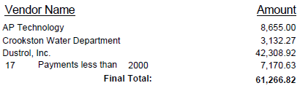
AUDITOR WARRANTS 12/03/2025
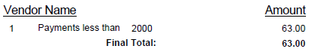

AUDITOR WARRANTS 12/04/2025
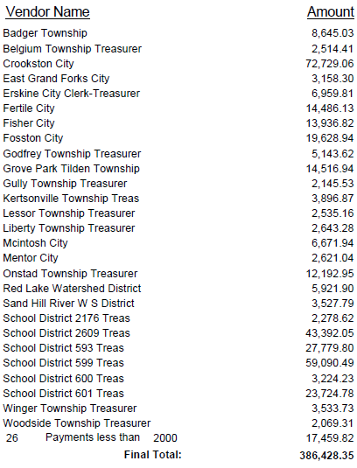

AUDITOR WARRANTS 12/05/2025
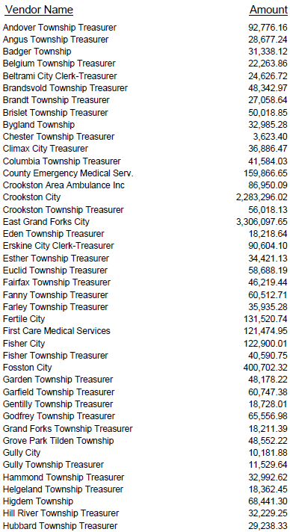
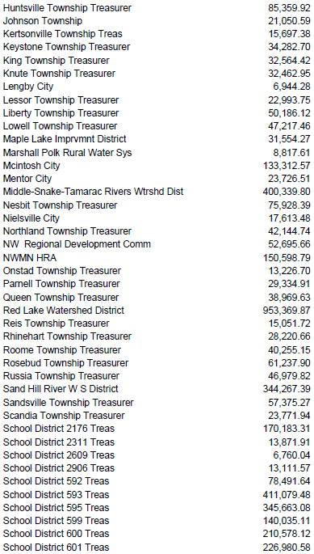
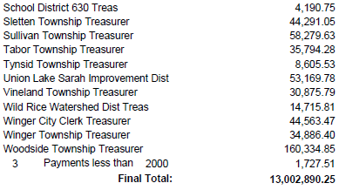
AUDITOR WARRANTS 12/10/2025
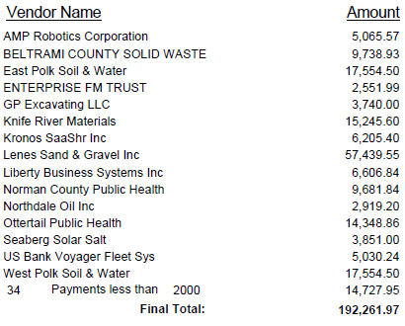
AUDITOR WARRANTS 12/11/2025
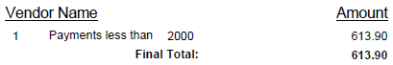
AUDITOR WARRANTS 12/15/2025
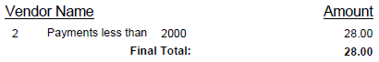

AUDITOR WARRANTS 12/17/2025
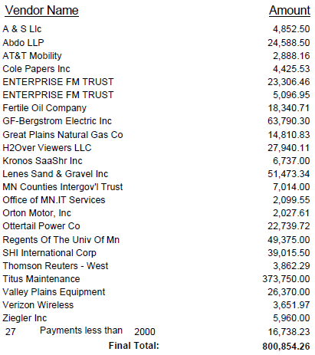
AUDITOR WARRANTS 12/23/2025
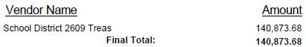

AUDITOR WARRANTS 12/24/2025
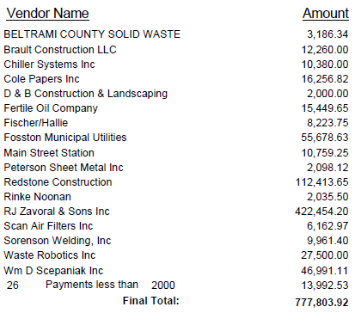
AUDITOR WARRANTS 12/31/2025
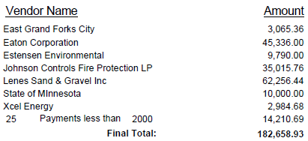
AUDITOR WARRANTS 12/31/2025
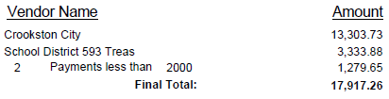

MANUAL WARRANTS 12/05/2025
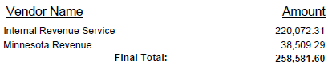
MANUAL WARRANTS 12/09/2025
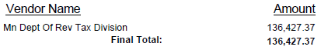
MANUAL WARRANTS 12/19/2025
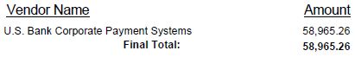
MANUAL WARRANTS 12/19/2025
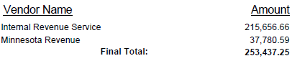
MANUAL WARRANTS 12/22/2025
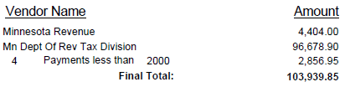

With no further business, the Board adjourned to reconvene at 9:30 o’clock a.m., January 20, 2026.

__________________________________________
, Chair

ATTEST:

____________________________________
Charles S. Whiting, County Administrator
Clerk of the Board

